Neeraj Asthana
nasthan2
CS 498: Applied Machine Learning
HW6 Report

Problem 1:
I used the “default_features_1059_tracks.txt” dataset to solve these problems. This dataset has 70 features or predictors and 1059 examples. All latitude and longitude values have been appropriately transformed to ensure that no negative values are predicted (scaled by 90 each).

1. Straightforward Linear Regression:
- Longitude Fit
  - R-squared: 0.3355
  - MSE: 1687.574
  - Diagnostic Plots:
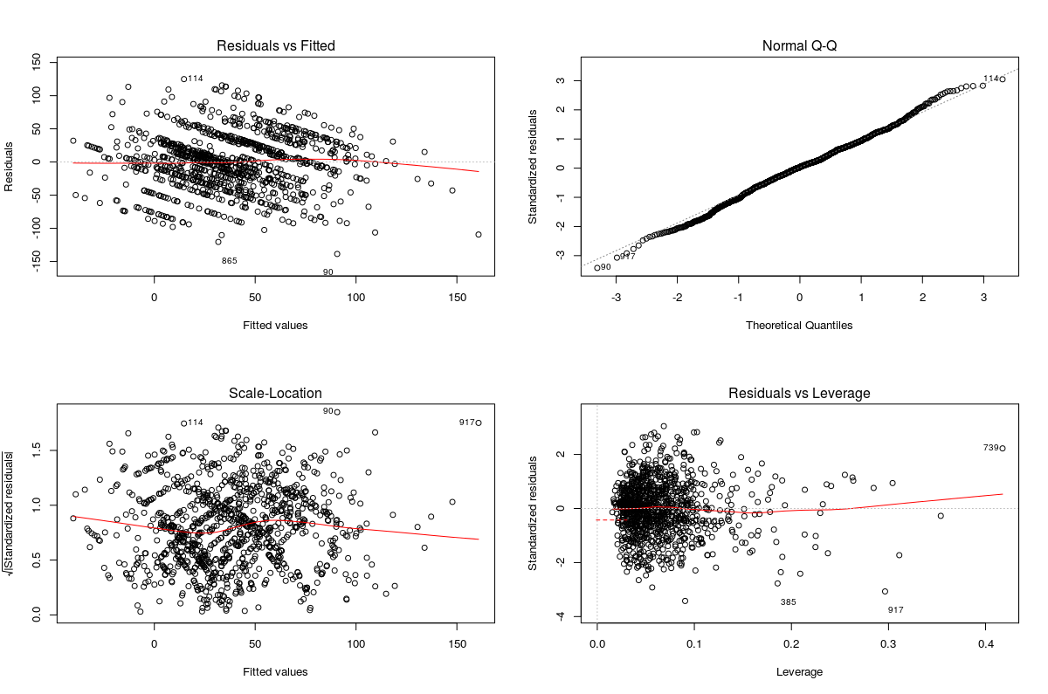
- Latitude Fit
  - R-squared: 0.29
  - MSE: 241.6968
  - Diagnostic Plots:
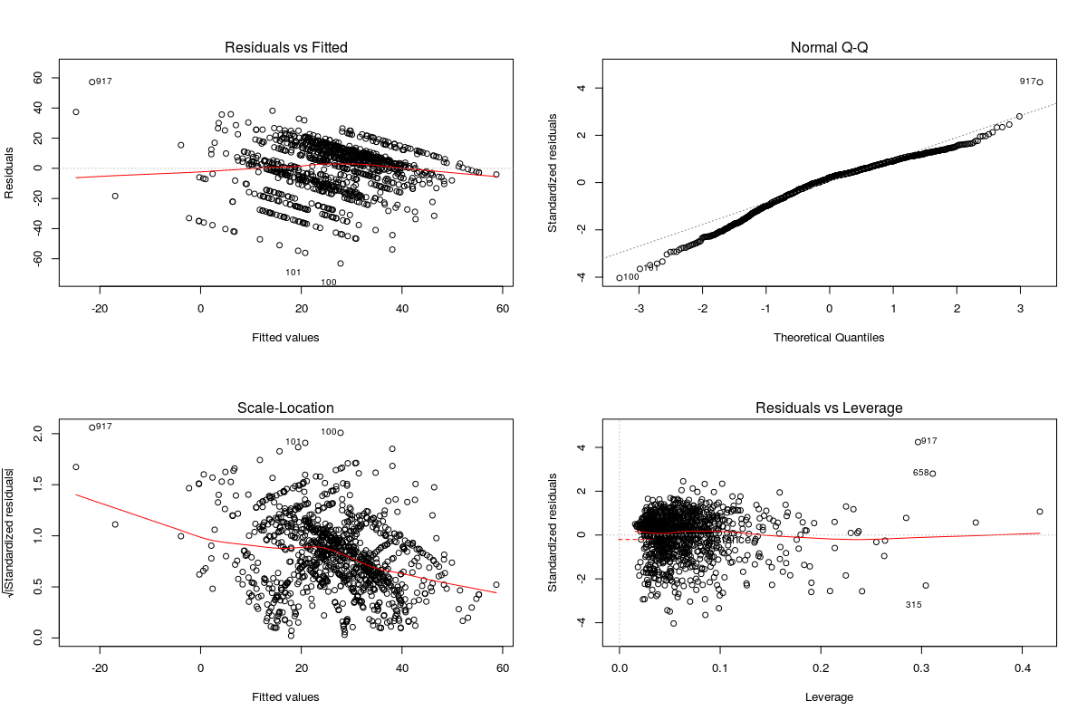

2. Box Cox Transformation
- Box Cox transformation for Latitude Fit:
  - The box cox plot suggests that a transformation of the latitude variable is necessary as the lambda value of 1 is not contained in the 95 % confidence interval. The plot below suggests a transformation of 3.5. Therefore I will create a new regression with the response variable being latitude^{3.5} (results and diagnostic plots for this new regresison are included below).
  - Plot:
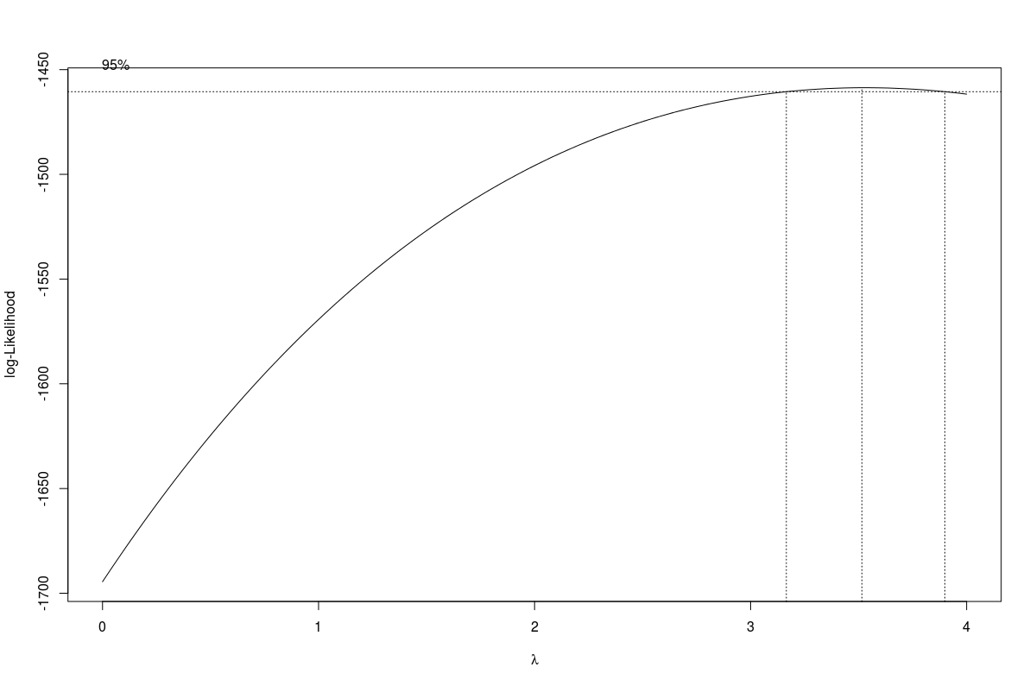
  - Transformed Latitude Fit Regression:
    - Lambda: 3.43
    - R-squared: 0.3185
    - MSE: 2.383951e+13
    - Diagnostic Plots:
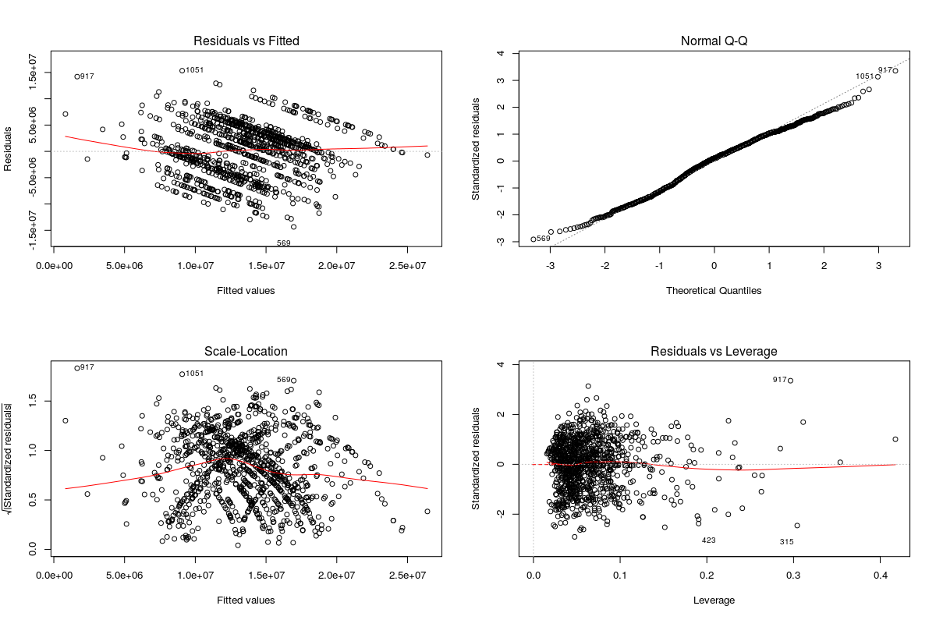
- Box Cox Transformation for Longitude Fit:
  - The box cox plot suggests that no transformation of the longitude variable is necessary as the lambda value of 1 is in the 95 % confidence interval. Therefore I will maintain to original linear regression model from before.
  - Plot:
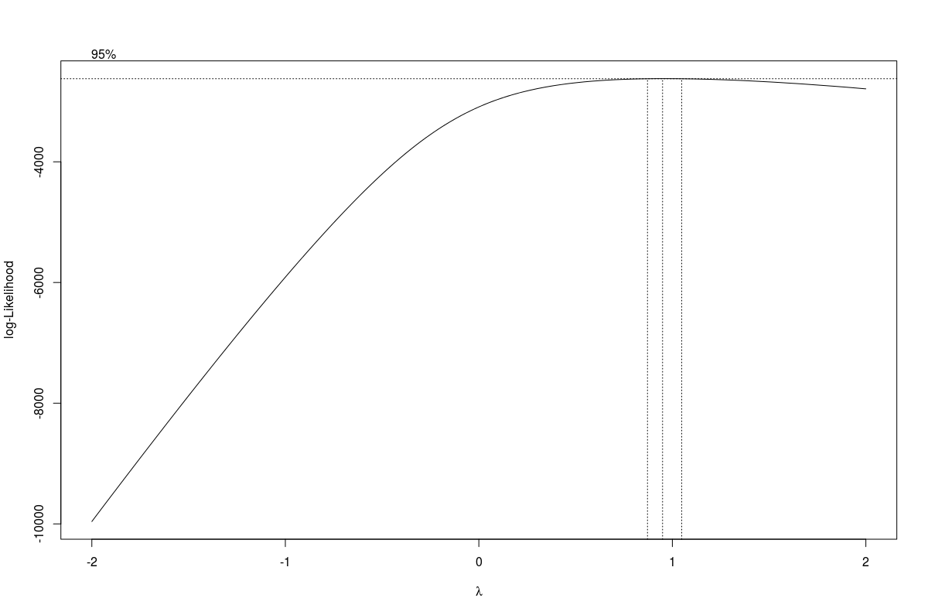
3. Ridge Regression:

4. Lasso Regression:

5. Elastic Net:

